1. copy the board I created before

Board address:<https://trello.com/b/IbXFiNmr/bug-tracker>

1. Click button of ‘...’

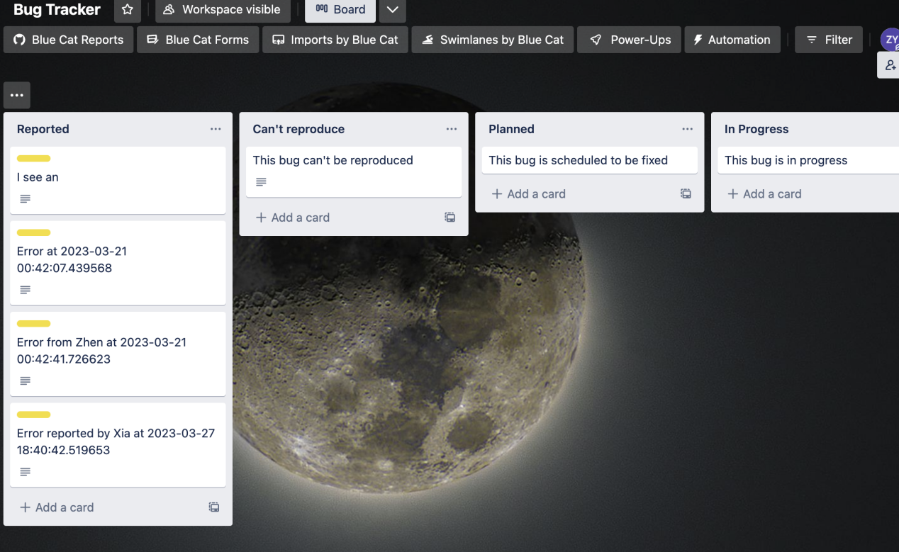

3. click more in the right menu

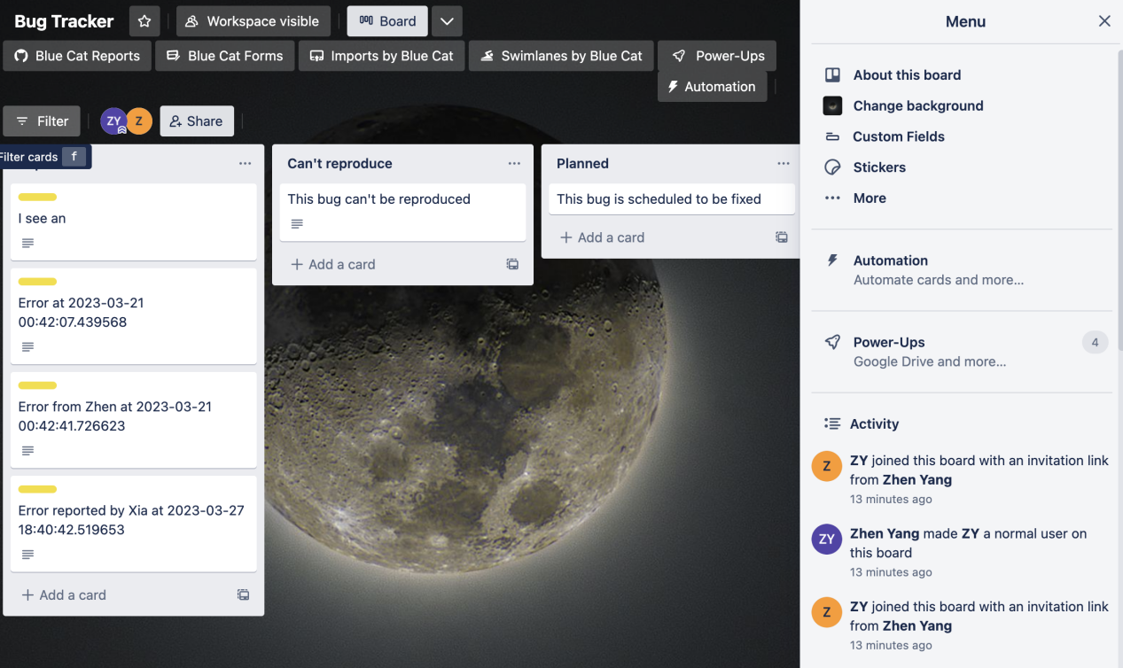

1. click copy board

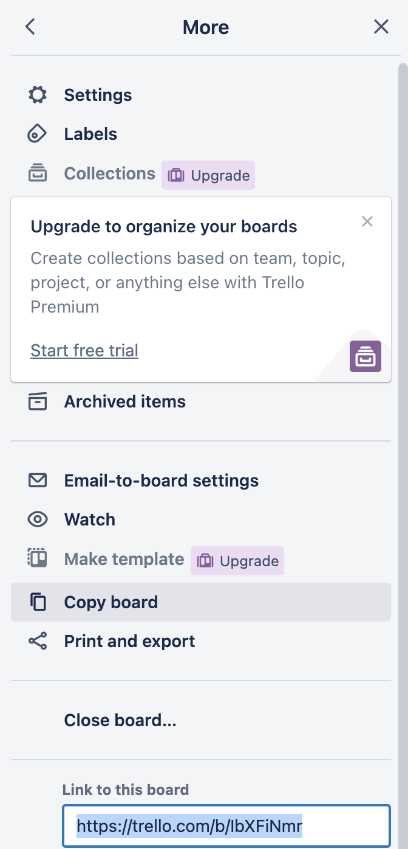

1. to link the board to our application

A. Get your API key:

Visit the Trello API key page: https://trello.com/app-key

Log in with your Trello account, if you haven't already.

You will see your API key displayed on the page. Make a note of it, as you'll need it later.

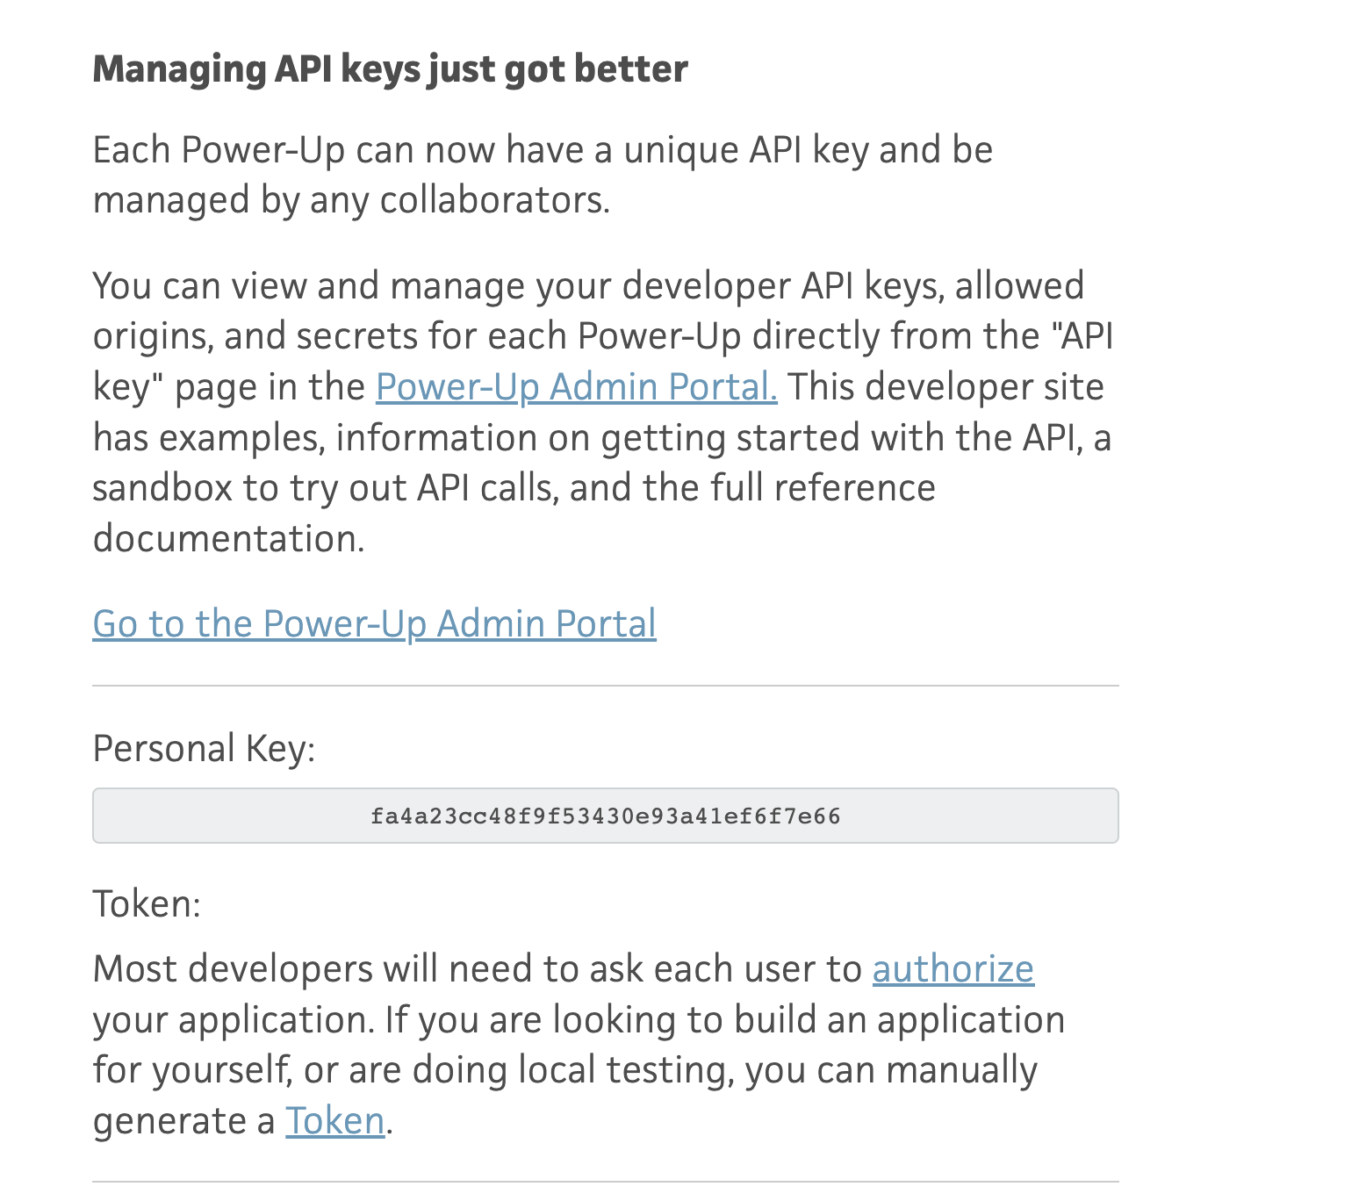

B. Generate your Trello token:

On the same API key page (https://trello.com/app-key), locate the "Token" section.

Click the "Token" link

1. paste the key and token to the application.py

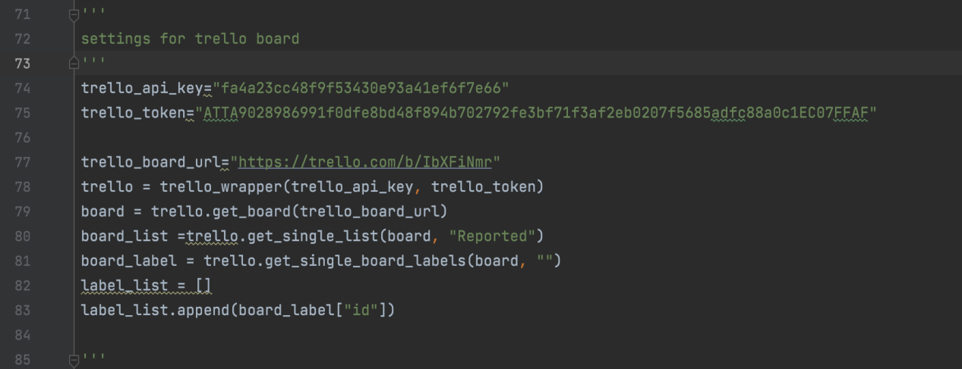

Replace the key, token and url variables with those of new board.

Set up a Trello account for the lab.

1. Register

We choose to go with google, after sign in google ([xiajiangw81x@gmail.com](mailto:xiajiangw81x@gmail.com)), then create an account with Trello.

2.

Copy the board that Zhen created previously to this new account. Go to the follow address

Board address :<https://trello.com/b/IbXFiNmr/bug-tracker>

Will be asked to log in (always use google to log in).

Once logged in, I received the following message:

After sending request, and zhen yang approved, clicked the board address again, was able to access the existing, then find copy board function to copy it see below.

The new board address:

https://trello.com/b/8Rr6Br2i/imedbot

1. Obtain the API Key and token. This is created for the JiangLab workspace. They can be used for any board created under this workspace, including the “borrowed” boards.

go to the following page.

https://trello.com/app-key

But it did not work. Should show a personal key like below, but it didn’t. This because Trello is working on the new procedure to create keys.

The new steps:

When logged in the Trello account, go to this page:

<https://trello.com/app-key>

Click [Power-Up Admin Portal](https://trello.com/power-ups/admin/). Click on new to generate a new key and token.

The current iMedbot board was created by Xia Jiang (originally created by Zhen Yang).

TO create a new API-key

Click generate a new API key

Once the new key is created, click on Token to get a token

When obtaining the token, a bunch of questions were asked:

Click on Allow to get token.

API key and token can always be obtained later from the previous page by clicking on API Key, once they are created.

1. Copy the API key (see blow), and paste to our code (application.py, around line 70)

4798d909048c0838ed33d43944c6be5c

Copy the token (see blow), and paste to our code (application.py, around line 70)

ATTA9240ff821b7c8af2ef43de23ef11a7695702f708e5726dbf50b1765956acde3909E08759

Also Updated the Trello board url in the code,

1. Re-deploy Imedbot-dev